Important dates during my PhD

Maybe the dichotomy of an experience??? A song sometimes for both the good and the bad, and maybe sometimes even the neutral.

TODO:

I have some ideas for images for a couple of my analogies, need to add in spots for those.

Think of a way to present the quote and song title (formatting of this thing)

**Why I’m writing this chapter-Flipside postlude**

A PhD ends in a finish full of triumphs: a published paper that will be used to inform the world of your research, a final defense that allows you to showcase all you’ve learned, and acceptance as an expert in your field. These triumphs are the fruits of intense labor and rigorous mental fortitude, but more often than not research is presented without mentioning the mental toll and important life moments that it took to succeed. Throughout graduate school I’ve missed out on holidays with family and friends, I write this chapter to identify with anyone who has ever felt inadequate, who has suffered from imposter syndrome, and who throughout failure nearly gave up. This chapter highlights my journey into a world of knowledge and success that I never thought I would have, and I hope it gives you some perspective on the daunting process that it takes to become an expert in an area of learning.

More personally, I feel that I haven’t truly been alive for most of my graduate school career. I’ve ignored family, friends, and the world in a way that I’ve never had to do before simply to try to succeed. The rest of the thesis is research and work, and when I saw this opportunity to write a personalized chapter, I couldn’t say no. I wanted to have a way to share more of my experiences with the people who haven’t gone through it and anyone who is curious about the mental toll that it takes to complete a PhD. Of course this experience isn’t universal I’m sure, but if you’re at all interested in what a minority experiences or feels throughout a graduate school experience, I hope to give you a bit of perspective.

Before I started writing this chapter, I asked myself how I could best personify this experience in a form that I feel embodies what I have gone through over the past 6 years. For years now, I have utilized the beauty that is streaming on spotify to catalog the music that I’ve been listening to in a monthly playlist. I’ve come to find that the songs that are in each of my monthly playlists somewhat embody the emotions that I was feeling that month; whether it was after a breakup, starting a new relationship, or just feeling lost within my mind, these songs capture my experiences and allow me to reflect on that time. It felt only fitting for me to close out the chapter of my life that was my PhD with a playlist of its own. Alongside these songs, I’ve shared reflections on my journey filled with the joys, the learning, and the dispare that I’ve personally experienced throughout my PhD. Feel free to read this chapter however you like (I preferred writing them with the songs of interest on repeat!), and I hope you enjoy the songs and stories that I’ve placed here. Thanks again for reading, and best of luck on whatever journey you are currently facing :D.

**Definitions**

Imposter syndrome

Protein design

Atom

Training grant

**I have a voice-Something Comforting by Porter Robinson**

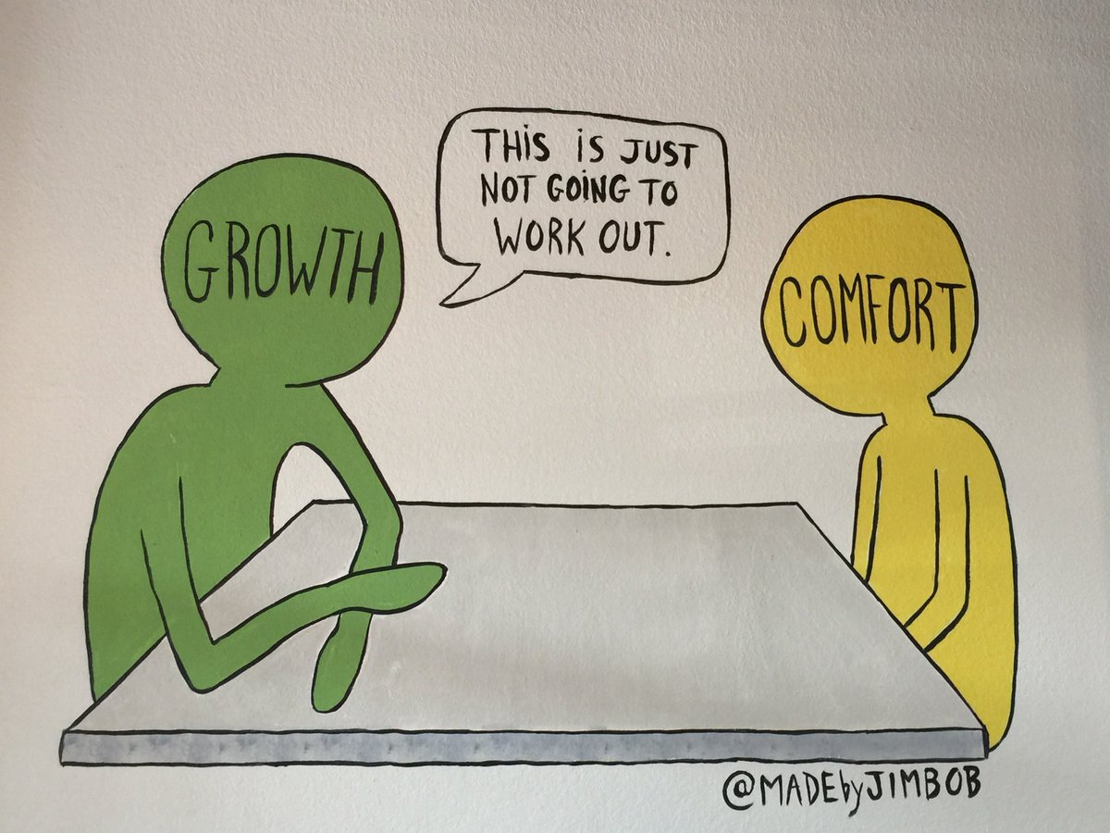

I don’t share my thoughts or opinions often, and I almost never raise my hand in class. For most situations in school I’ve almost always lacked the confidence to share. But in my first year of graduate school, I noticed that something was different about many classes. Instead of lectures or being taught at, many professors held classes as a conversation: the lesson plan wasn’t strict, and it was dependent on what we as students were most curious about. A couple months into my first semester, one of these professors asked: “What are your goals with your graduate education?” No one raised their hand, so instead of just waiting, he started to call on people. Some people answered to progress research, to get into industry to make life changing money, or to mentor students in a teaching environment. But when I was called on, I didn’t have a straightforward answer or thought in my head, so I said I wasn’t sure. Yet he encouraged me to say anything that felt right. Emboldened, I allowed my mind to drift, focusing on thoughts that felt distant but became closer. I thought of the things I didn’t like about teaching that could be improved, and the things that I might enjoy working on in the future, until finally I said: “I want to find a way to replace PowerPoint.”

I look back on that day with both a bit of fondness. Although I will likely never revolutionize the way that presentations are being done, that opportunity to speak my mind and to share something wild and against the grain in a public space gave me confidence to share my thoughts and ideas. This is the environment I’ve been exposed to for the last 7 years where I’m actively encouraged by mentors and peers to share my thoughts and ideas. It inspires a free flow of learning and knowledge, of questions and ideas both within and outside of research. Questions from “How do you feel like doing this experiment could change your results?” to “What kind of things do you think we can do to benefit the students in our organization?”. Although there have been fleeting moments in my schooling where I have felt this way, this is the most sustained feeling of being able to share ideas openly, allowing myself to be heard.

It led me to a simple discovery that I wish I had sooner: I have a voice. One that can be used to share my ideas freely, even if they’re half baked or if they might be wrong. But why didn’t I feel this way before? Why did it take me over 22 years to understand that my voice, my thoughts, and my opinions matter? Why have I felt judged and alienated whenever I have a thought that promotes differences in thinking? I picked Something Comforting because I feel like it kinda captures these two ideas:

**'Cause getting made you want more  
And hoping made you hurt more  
Oh, there must be  
Something wrong with me**

That dichotomy of wanting to be accepted, hoping that in the future it does, but having to ponder on these negative thoughts about why I am the way I am. I don’t have all of the answers yet, but I find comfort in my friends, family, mentors, and music that have brought me here. I’ve learned to focus on what my words mean and if they make sense to me. I’m still afraid of being judged, and sometimes I don’t share my thoughts for that reason, but instead of bottling those up, I’ve found that there are times and places that are comfortable for sharing. I’ve grown a lot just from having the opportunities to explore and express myself mentally both inside and outside of science, and I hope that I’ll be able to successfully continue sharing my ideas in whatever I do in the future.

**Prelim 1 Atlas-keshi**

In graduate school, the preliminary exam puts me into a room with 5 professors who each have many, **many** scientific publications to each of their names. I’m expected to talk about the beginnings of a project that I’m supposed to be the expert of AND complete within the next 4-6 years. They ask me questions about tiny details I hadn’t yet thought about, and they expect me to tell them the right answer:

“What’s the definition of van der Waals?

What will you do if this experiment doesn’t work as you expect?

If a tree falls in a forest and no one is around to hear it, does it make a sound?”

After an hour and a half, I leave the room, deflated, exasperated, mind afloat. I finally remember to breathe. Other students passed me by in the hallway and congratulate me, telling me that the worst is over. I’m ready to move on and get back to doing the science that I love. I walk back into the room to hear how they felt about my project, my presentation, my ability as a scientist…and they begin with “Thank you for the presentation. We think your progress has promise, but we can’t give you a pass at this time. There are some weaknesses…”. They didn’t say the word, but I’ve tuned everything else out and I know what it all means. I’ve failed.

For many prelim exam failures, there is no second chance. I’ve had the opportunity to prove my ability to move forward to do independent research, but what if I didn’t do enough to show that I had the potential to succeed?

“…However, we do think that you’re making progress and look forward to seeing you have another opportunity next year.”

Not a pass, but not a complete fail. I couldn’t have expected it at all. But maybe I should have.

A logic knot. Imagine your thoughts are written along a straight piece of rope. When two separate thoughts collide, a knot starts to form. Any thoughts in the middle are stuck within the knot and you can no longer proceed to the next thought. Literally stuck in thought.

The prelim led me to finding myself in a logic knot based on my identity and ability to succeed in graduate school. A lot of suppressed observations start to creep into my head and don’t leave:

* I’m one of the few black people in my research program
* I’m one of the few people who failed prelim
* I’m one of the few people who get’s a second chance
* Could the reason that I’m one of the few black people here be because I’m not actually supposed to be here?

**I don’t belong here, let me start over**

**I wanna sleep so wake me up when I’m older**

This song felt right. After failing my prelim, these words pulsed through my head constantly. I’ve viewed my identity and my culture as something to be embraced and celebrated. But with this I personally had a moment where I had to reflect on how being a minority has made me think. Why was I rejected from almost all labs in my undergrad except one? Why do I feel many times that I don’t deserve the successes that I receive? And why now does this experience feel like I should have seen it coming? Finally instead of solely appreciating my values, I began to see how limiting they can seem. To not see anyone in my field who looks like me, and to simultaneously fail at something that I really want shook me to the core of my being, altered my foundation, breaking and molding me back together into some slightly misshapen version of yourself. I had to rethink what it means to be me, and to evaluate myself to see if I could actually succeed in graduate school.

**Black in STEM/Imposter Syndrome**

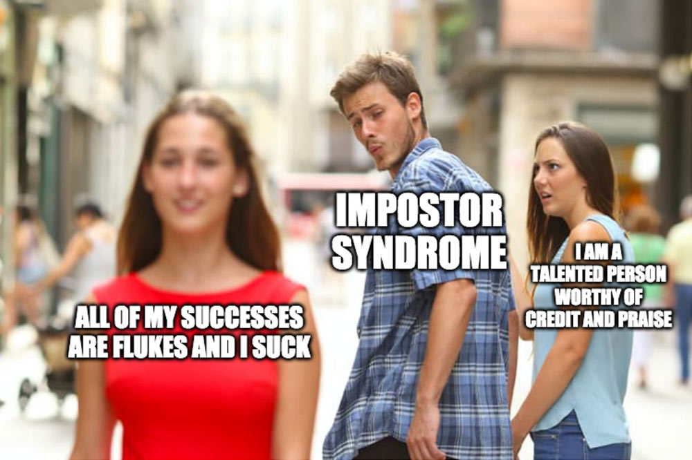

One of the most difficult parts of being in grad school in Wisconsin is the lack of diversity. Whether it be in the types of food or the types of people, this place has a small amount of minority students that look like me. And when things go either positively or negatively, I wonder if it partially has something to do with my race and ethnicity.

At the end of my first year in graduate school, I applied for a program that would fund my graduate research. The application and interview process were quite interesting, asking me to give an elevator pitch on my research. I had friends who also interviewed for the program and eagerly awaited the response, hoping that we’d all get in. When the email arrived, I scrolled down to the accepted names and saw mine, but no names of any of my friends. The next time I ran into one of them, we chatted about this and the interview process and how the first meeting was, and they wondered aloud why I was accepted instead of them. And I personally felt how engrained this idea was in the moment when I responded:

“They’re going through a review process this year, and there aren’t many minorities in the program, so they might have wanted to increase diversity”

In both successes (this program) and failures (prelim), there is the default in my mind to attribute it to my identity. It’s not that I reject I think I have the ability to succeed or that I don’t think that I have the intelligence to not fail, but when you know how the world perceives you, you begin to perceive yourself in the same way.

**Terrified, paranoid, I'll put you over everything to fill the void  
And when you’re gone, will I have anything or will I be destroyed?**

I started to see myself in a slightly different light: I’m made up of my experiences, and many of those experiences have been quite negative to my perception of myself. Like imagine … allusion/movie reference. In order to figure it out I realized that I would have to focus even more on myself. Shutting out many relationships in order to get past this part of my life. I wanted to learn enough to pass my second prelim, and to do so I needed to learn a lot of science and about myself. (can I tie this in to earlier with my learning about my voice?)

**Post prelim I always wanna die sometimes**

The other day as I was waiting for the bus, I had this dark notion. My head felt heavy and everything appeared to go black. I could feel that my eyes were open, yet I saw an empty all around me. A pulsing thought flitted back and forth in my head:

“What if…”

You’re just tired

“you could…”

you’ll be okay soon, “just” a bit longer

but it’s more than a bit

“jump…”

there’s a lot left “…in front of …” you to do

should you eat today

“…the bus” is here

And the color came back. A typical cloudy, desolate gray reflecting off back and forth between the clouds and the cement road.

I’ve had a variety of small bouts with depression in the past, but this one was different. Stronger, more empty. I’ve wanted to disappear before, but never to the extent that the little evil thoughts in my head were able to come out so clear. After a month or so of these thoughts, I returned to therapy.

Stating things is freeing. Much of the time I’m able to listen to the thoughts in my head, rationalize them and reflect enough where I’m typically fine. Able to enjoy life rather than simply existing in it. But this time was different. After failing my prelim, I was more of a shell of myself than ever before. I lost both the desire and motivation to live, so much so that in times where I had nothing pressing to do or scheduled, I would literally be unable to get my brain to move my body. To be able to think “Move”, “get up”, “go over there” but my body was left motionless, unfunctioning.

After a set of sessions, my therapist was able to get me back to myself with just two words of advice: “Take risks”. **\*build this up a bit**

It allowed me to move past it by asking myself the following question: Is it riskier to remove myself from this difficult situation and leave research OR to trek through the difficult road I have ahead? It pushed me to not be satisfied with where I’m currently at. Rather than continuing to just try the same thing, remaining complacent, I know that I should take risks to try to be more satisfied with where I’m at in life. Whether or not I pushed ahead and failed the next time, I will have learned a lot. I love learning, and losing that valuable experience and knowledge was riskier in my opinion.

I’ve learned to accept myself at a deeper level, and I now know the limits that I can push my body and mind to accomplish learning something. (examples?)Outside of the obviousness of the song title and the lyrics alluding to suicide, the sounds of this song are what really resonate with me. The strings fill you with this hopeful melancholy that is accentuated by the (harmonizer? Piano like thing?), and the chorus bursts it all into this sound with the guitar while countered by the (harmonizer thing) that makes me picture as the first stages of growth of a daisy where the seed roots out of the ground and the petal take shape. Before bringing it all back to earth with the ending strings where rain start to pour on the sprouted plant and the daisy bulb is now depressed into a drooping motion because of the intensity of the rain drops falling.

**Shout out to all of the friend who supported me. I didn’t know what I needed at the time, but the camaraderie of the ones who asked me how I was doing, shared their own experiences with me, and continued to watch me grow along the way saved me.**

**Into the Woods**

This one is kind of a thanks for taking this pensive journey with me. There have been times when I’ve felt completely lost and broken, and others where I’ve been excited for what’s to come. Despite how different those feelings might be, I’ve found myself closing my eyes relistening to this song on repeat. The fear of walking through a foggy set of woods as well as the excitement of the discovery waiting ahead. Whether you’ve read through and identify with me in some way, are just curious and wanted to understand my graduate school experience, or if you’re a random person reading this somewhere, thanks for being here now. I hope that wherever you are on your journey that you’re able to find some solace, and some happiness.

**First day my design program worked**

* Details:
  + Days I would lay on my floor, imagining how atoms move and then crying because I’m unsure if I understand things properly

During the pandemic, I was pretty fortunate to have

**Prelim 2: 5 year plan-Chance the Rapper**

This song came out shortly after I passed my prelim, and I identified with it immediately. The chords remind me of a sunshower; the sprinkle of refracted sunlight, dancing on your skin.

While I was out for a walk an hour before my prelim, I thought of the following question: Did you ever think of how you could impact humanity as a child? I remember wondering how I could make some contribution, if that’s even possible for me to do. What does it take to do that and how do those people feel?

It’s not the biggest thing, and my research likely isn’t going to be used for anything impactful. But it’ll be a small bubble on the expansion of human knowledge.

Know what you don’t know. This was the motto that Alessandro preached to me as we got closer to my second prelim. …details on this here…maybe just what it means to me and how it helped me? With the addition of defining it properly and how it’s been impactful?

**Time has come, take it all in**

Add in an image of how I picture the expansion of knowledge (little blip on a bubble)

**When you’re breaking my heart**

Maybe when I got that poor data from sort seq the first time? Everything feels right and is so close with my first set of big data,

In a lot of ways, I’ve begun to picture my PhD as a person. In over 6 years, I’ve learned a lot about myself and it, while

Talking about anxiety: going from big to small. I need to go do this big experiment, I need to prep for a meeting in a couple weeks, I need to do this smaller code thing, I need to eat something healthy, I need to eat, I need to get off my phone and sleep, I need to get out of bed, I need to shower, etc. Just some way to detail how the small things are becoming big things.

Making it relatable: I’ve always been interested in the imagination. Something akin to animation, cartoons, pushing the boundaries of what people understand and can think about in a new format…relates me to the science

**Off day by Lyn Lapid**

For a couple of months during my final fall semester at UW, I felt a haze. My brain was deep in fog, causing me to actively search for a way out. It was constantly active, thinking of new ideas and wanting to work. And so I began to realize that I couldn’t sleep.

After a couple weeks of being unable to sleep well, I gave up. Instead of sitting in bed and doing nothing, I succumbed and decided: welp, if I can’t do anything else right now, might as well get some work done in lab.

I’ve been in during odd hours before to finish experiments at times when I’m not satisfied with my work, or when things have gone wrong, filled with anguish and hoping things work. But this time I didn’t feel stressed or in a rush. I felt calm. Like just knowing there’s an ending to this research, this experience, is allowing me to look back on these days a bit more fondly. Yes, the work is always on my mind, preventing me from thinking about anything else or not thinking at all. But it’s almost over and I’ll miss these moments.

I’ll miss taking days to think and test different ideas, to decide when to do an experiment, the freedom to work these odd hours.

Graduate school is quite a special place. This environment pushes you towards discovery: time is given to allow your brain to acclimate to the idea of working at the boundary of human knowledge, allowing you to excise your biases in pursuit of truth. Do you remember any days when you were a child? When you could just take the time to stare at the sky, and let thoughts freely flow in and out of your mind? I feel like graduate school harnesses this latent ability, allowing you to explore deeper within your current understanding of some subset of knowledge. More often near the end of this tenure I’ve wondered if I would recommend graduate school to others. I think it definitely depends on the person, but if you enjoyed those childlike moments of discovery and the time to think, it just might be for you.

This song to me expresses the current bout of feelings that I’m going through during grad school: the hook is particularly connecting with me, “you don’t cross my mind, you live in it”. It feels like it bundles you up in a freshly washed and dried blanket on a cold winter day. Comfortable and calm, reassuring warmth. My work is always on my mind, but the coziness of it fading allows me to reflect within these moments of peace.

**Autopilot**

Write about the day I realized that I’ve literally done 1000 so something in my grad school career

Over New Year’s I was finishing up a set of experiments and I realized something: I’ve done this same experimental process at least 1000 times. This experiment is known as a miniprep, where we purify DNA from bacteria (and walk through the process with an image).

I’ve gotten so comfortable with the process that I can basically do this and other parts of my research on autopilot. A lot of graduate school is based on thinking and learning, understanding problems that arise, and adjusting to them. But these parts of being an expert in a technique are just as important despite their simplicity. …what else to mention here…?

How the being on autopilot slows my intrusive thoughts **(define)** but also makes me feel a bit more prone to feel like I’m not doing anything important.

Talk about how everyday has become reminding myself that I’ve done enough work even though it feels unproductive

Other writing options:

Admissions committee

SciMed

Finally a short list of the pros and cons of a PhD that I came up with

Pros:

* Learn more then you probably ever imagined could be learned
* Become a foundation for creating new knowledge
* Hone your ability to learn and know what you don’t know
* Freedom to work at your own pace and on your own time schedule

Cons:

* Low pay and LONG hours

Channel of negative thoughts. Sometimes it flips on and every channel is it

**Key questions:**

* How does it feel to almost receive a PhD as a minority in stem? What would you say surprised you the most about the experience?
* When did you most feel like an imposter?
* What did you learn from yourself whenever you burned out?
  + Kind works of encouragement for myself are needed/talking to myself through my problems and issues

**Guidelines for my writing**

* I think after here, it’s about getting punchy titles that work well with my song choice. It would be nice if the titles were tied to lessons of the stories that I aim to tell. This first example below is more of a lesson than a story, so I’ll have to change that around a bit.
* One thing that I’ve found myself not doing well is SHOWING the story. I think my memory right now is hinging on an experience rather than actually drawing out a specific portion of the memory. Draw out that first and then expound upon it.
* I think I figured it out. I’m going to picture I’m writing to TA, the person who I’ve wrote the most letters to in my life. I think that voice will flow out a bit more freely.
* And finally, end it with how the song fits by describing and picturing the sound (close your eyes, listen, and sing along)